Authentic Learning
Abdullah Sujee
Principal
Roshnee Islamic School
P.O.Box 21313, Roshnee, 1936.
15 Babas Salaam St. Dadaville.
Tel. No. (016) 556-1146. Fax. No.: (016) 556-1177.
Email: abdullahsuje@telkomsa.net. OR abdullahsujee@hotmail.com

Abstract:
New technologies will not invalidate existing reasons for learning to read and write.
- Reading gives access to knowledge, literary heritage, culture, individual expression and argument.
- Writing enables groups and individuals to articulate and reform knowledge express themselves and develop arguments.
- Literacy is necessary for effective functioning at work and in society.
- Both reading and writing give pleasure and personal fulfilment.
Reading is informed by understanding where texts come from and who has written them, how they are made and why they are made. Writing their own texts helps learners to develop that understanding.

New technologies for reading and writing have extended the curriculum for English.
Students now need opportunities to understand:
- how the use of word processors, spell checkers and thesauruses affects the processes involved in the different stages of composition and presentation of text;
- how the research opportunities offered by CD-ROM and Internet-based services can be used to support the literature and language;
- how the use of electronic sources of information can enhance the processes of comparison and synthesis of information drawn from different texts;
- how the use of the Internet extends and changes possibilities for communication with, and publishing for, real audiences across the world.
ENGLISH FOR TOMORROW, SALLY TWEEDLE ET AL.
Therefore, Authentic Learning is the integration of real historical events in the teaching of English such that the classroom becomes the springboard to the world beyond it. In effect this diminishes the misnomer that the ‘real world’ is ‘outside’ the domain of the classroom or the school. WHEN WHAT WE TEACH IS NOT MADE AUTHENTIC THROUGH EXPERIENCE THEN, WE HAVE ONLY PASSED ON INFORMATION.
Keywords: Truth and Reconciliation Commission, Audio recordings, integrated computer technology, fast capitalism, world of the classroom, media integration, classroom a conduit to the world beyond it.

Introduction – Preamble
The dynamics of education has always been welded to politics in such a way that it channels the status quo in preparing the mindset of the masses. When the status quo is an acceptable type of democracy, it allows you to use the historical past as a means to establish a new future of possibilities. The education of the nation must not serve to overwhelm the historical past but, it must show how in an objective sense how the past made the future happen. Therefore, an education system that does not allow for this progression to develop will eventually become irrelevant because, education is the keystone to human progression from being uncivilised to being civilised.
- Abdullah Sujee.

Opening Remarks:
The notion of teaching literature beyond the scope of what the text presents is very difficult when we believe that literature is textually based and that its meaning and decoding is within itself. However, when we begin to establish the context that led to the actual writing of the novel, drama, short story or poem and the closest historical connection with it, the actual genre of literature study becomes alive and authentic. In effect, the extended notion that fiction is only based on ‘untrue’ issues can be viewed differently in that many fictional texts have some strong historical truths that inform the story line or, allow the writer to create a new thrill around an old event. Therefore, the paper explores authentic learning in a way where actual historical events can be part of the teaching of literature.

The Lesson idea
In my last paper, Teaching with Flair, I explored the idea of using an integrated workbook approach together with ICTs in teaching literature and found that it can be extended. In the teaching of Alan Paton’s Cry, The Beloved Country, I found that for many of the learners Apartheid seemed like a myth and in some cases a fictional event. Despite all the history that we see in South Africa about Apartheid – Robben Island, Aparthed Museum, the Sharpeville memorial precinct, Hector Peterson memorial to name but a few – the reality of it is far fetched for the pupils. Therefore, the historical Truth and Reconciliation Commission set up by Bishop Desmond Tutu gave me the idea of using that concept in a very different way to make apartheid ‘real’ for the learners so that they would be able to comprehend in more concrete ways what apartheid actually was.

Three months prior to starting the teaching of the novel, I introduced learners through the RCL and its Clubs and societies about the Apartheid activists in our locality of Roshnee and the Vaal. They were told that we would interview them and publish their ‘stories’ in our school’s newspaper and then do a full publication of all the stories in a book form. We would write to the TRC and inform them of our idea and hope that they will publish the book. At the same time I would begin pave the way of this idea with my learners in class i.e. the grade 10s. In effect, during their study of the play, Julius Caesar, and their completed audio assignment on the play, this idea was a challenge. However, all of them did not respond as that is life. Therefore, I began working with a core group of pupils mixed up of all grades with the bulk from grade 10.

The Ground Work
The learners were then introduced to the various activists in Roshnee against Apartheid and they began their first interview. It was deliberate plan that I did not make myself part of the interview but informed the activists about what was going down. The group of 12 at the time (Jan.07 – April 07) learners held their first interviews and that was all to put them on a roller-coaster. We then began making contact with the likes of Dr.Jassat who was prepared to get us to meet with Bishop Desmond Tutu and probably Mr.Mandela himself to bolster our efforts. We made contact with Mr.Firose Cachalia and his wife for interviews as well to further bolster our efforts. The hearings now got the name: “The Vaal Hearings”
The story on this is still been written…

The idea working in the classroom
The classroom must reflect the world beyond it because the classroom is the real world itself save that we have compartmentalised it into some kind of cartoon like world because, we continue to get the edge of our learners by telling them that ‘…wait till you get in the real world and then see…’Therefore, the idea in the classroom would work like this:

The video footage and audio recordings of all of the activists that we interviewed would be played in class when the introduction to Alan Paton’s context for writing the novel Cry, the Beloved Country. The activists themselves would be invited in person to actually tell the learners their experiences during apartheid to make the issues in the novel more real and authentic. These visits are planned and organised in such a way that they would come in class, tell their bit and would respond to a part of the novel i.e. for example when the issue of the Dompas (the ID type document that all blacks had to carry to avoid arrest). In this way the novel would become alive.

The context of the novel is made real and then the reality of the protest poetry that goes along with the context of the novel becomes more real and the learning is now definitely authentic. Furthermore, the activists would be asked about their future thoughts of South Africa and this again would tie in with the novel and its fictional ending yet, making the learners realise that the history is real and that is what informed the actual narrative.

Children of the South African Democratic era cannot fathom the human right violations of Apartheid – in the words of a grade 10 pupil, Fatima Khaki: “…for me Aparthied seemed like a figment of my imagination until I did the Vaal Hearings…reality hit me like thunderbolt…”

Progressing from the idea of audio productions (See Teaching with Flair document), pupils used this skill learnt in class to interview activists. Thereafter, a select group of pupils from within grade 10 and the Clubs and Societies would be selected to host my radio show on Cii – Educational Forum: 8-9pm CAT on Worldspace : http://www.channelislam.com/broadcasting/totunein.htm
12 January 2008 – the pupils hosted the programme and interviewed some the activists.

During December 2007 and January 2008 they would host activists that were interviewed so that the idea and concept of the ‘Vaal Hearings’ become more concretised. This would make the idea world known thus, extending the boundaries of learning.

Development of the idea: Content, Community, Collaboration and Context.
- Pupils were then introduced to Blogspots. They had to set up their own blogspot and amongst the various posts they had to make were that of their interview they did and the reflective essay based on the interview. Thereafter, we set up the blogspot for all the interviews we did. You will access it on http://vaalhearings.blogspot.com/

- Collaboration with teachers from various parts of the world was made though email and the response was from Marsha Goren from Occupied Palestine. The pupils have made contact with her to establish how they can get in touch with holocaust survivors so as to make real their understanding of oppression.

- Pupils were then requested to write book for gr.4 – 6 on the TRC using their interview ‘character’. The books are due in term 4 of 2007 and would then be given to the grade 4 – 6 teachers for actual use in their classes for feedback, evaluation and reviews. This will be prepare them for the final stage,

- They will use the skill of the above and tweak it such that now they would be able to write a book on the Vaal Hearings and published it in 2008. The book will be a compilation of all the ‘hearings’ in an autobiographical style and would include a selection of pupils’ reflective essays to illustrate the lessons learnt.

- In the meantime, collaboration with people who have come on board will be taken to the next level i.e. they should begin their blogspots where there will post their ‘interviews’ so that the process of awareness is made more real and global. This process we hope will be completed in June 2008.

The Idea related to CONTENT

- The novel’s, Cry, the Beloved Country, content is very traditional save that they had to make that learning real. For example, they had to actually visit a township/shanty town, build models around it and do play & PowerPoint presentation on it. In effect, you see the novel’s themes come to life.
- The above is scalable with any novel of social protest – think of how Orwell’s Animal Farm, or Dicken’s Tale of Two Cities or Steinbeck’s Grapes of Wrath can be used in the same grain to make the issues more real and ‘alive’! One needs to work at innovatively.
- Pupils will enhance their creative writing skills. They will first write their own CHILDRENS book based on the TRC using their interviews. This will be a training phase in identifying audience and writing for them. In effect, this would prepare them to write the book on the Vaal Hearings that we intend to publish in 2008. The book will be for an adult audience and therefore, they would need to have more refined writing skills and would have to identify with audience more widely.
  - Two Pupils’ children’s books have been handed in as at 19 September 2007 while the balance will be handed in on 1 October 2007. A competition was held for the pupils i.e. the pupil that hands in the book by 19 September 2007 would receive a prize – an ICT prize (digital writing pad) and the second prize – an ICT prize : 1gig flash drive. It was an amazing day when the two pupils got their prizes.
- The idea is such that pupils who you do teach can join the project through the existing clubs and societies in the school.
*****RESULT OF # 4
  - Attiyyah Saloojee of grade 11 – I do not teach her i.e. English. However, being involved in the RIS Independent Newspaper she became part of the project and used the project to enter the 17 TOP TEEN ACHIEVERS AWARD IN SOUTH AFRICA and she was one of 4 finalists as at 18 September 2007. In her words she said: “The idea of working with the ‘Vaal Hearings’ projected me onto a new level of thinking in that it made me work with people beyond my community. Furthermore, it has given me an edge over many when it comes to communication skills and language learning as a whole.” – 20 Sep. 07. In effect one sees how the classroom, the school and the world beyond it become conduits for holistic learning.

The Idea related to COMMUNITY:

- The idea lent itself to pupils making inroads into the community (Roshnee) they are living in and communities beyond. They made contact with people they did not know. For example, they interviewed Mr.Baboo Kajee, a former MK (Military Wing of the ANC) member and many other such people.
- They met people like Mrs Molema, the wife of the ANC Cadre, Cd. B.J.Molema. She lives in a small holding 15km away from Roshnee.
- They met with people like Mr.Yunus Shaik and learnt how people from across SA became involved in the struggle against Apartheid.
- The amazing thing was that many of these interviews were done at night – pupils and I travelled together to places and in many cases parents would take them for the interviews as well. This made parents connect with the pupils in ways that enriched their understanding of people as well.
- Pupils are now more keen to know of other people doing other things in the community that changed history of the community.
- # 5 above made me meet with Mr.Yunus Chamda – former Mayor of the Vaal and resident of Roshnee – he is keen on doing a history of Roshnee and he suggested that my pupils help him. When I talked to him about the Vaal Hearings i.e. after inviting him on board, he mentioned that the idea is a good one and that it can work.

The Idea related to COLLABORATION:

- The idea allowed us to network. This networking extended beyond the boundaries of South Africa and it reached many people – however, we are still awaiting responses.
- The following responses made the idea more concrete:
  - The Office of Bishop Desmond Tutu – it is clear that we would in the near future meet or have more contact with Bishop Tutu – see blogspot for the full reply from the Bishop’s Office.
  - The letter to the PA of Mr.Mandela, Mrs.Zelda Le Grange, is pending and Dr.Jassat, a former member of Parliament who works closely with Mr.Mandela, said that he would follow up on this correspondence.
  - The secretary of AMS (Association of Muslim Schools) has given us his support and got pupils to work on aspects of the idea – again see blogspot for detailed letter and reply.
  - Marsha Goren from Occupied Palestine is also willing to share ideas – two students will have started emailing her and to share ideas.
  - The idea is also expanding to communities like Sharpeville where the heart of the struggle began. Here we will be dedicating much of 2008 because it will be opportune in terms of our calendar of the school’s social outreach programme. The school we will be working with is L.Shandu. Correspondence sent on 20 Sep. 07. (See Memorandum of Understanding below)
  - We would also be extending our idea to the curator of the Sharpeville Memorial Precinct – this will be expanded in 2008.
  - We hope therefore, when we would work the Office of the Bishop from which we will source a FOREWARD to the book.
  - Progressing from the idea of audio productions (See Teaching with Flair document), pupils used this skill learnt in class to interview activists. Thereafter, a select group of pupils from within grade 10 and the Clubs and Societies would be selected to host my radio show on Cii – Educational Forum: 8-9pm CAT on Worldspace : http://www.channelislam.com/broadcasting/totunein.htm

During December 2007 and January 2008 they would host activists that were interviewed so that the idea and concept of the ‘Vaal Hearings’ become more concretised. This would make the idea world known thus, extending the boundaries of learning
- Jeanette Le Fleur a student from the West Indies who is doing her masters in Education and focusing on ICTs in the teaching has been attending my classed for the 3 -4 weeks (July – September 2007) to gain insight into the use of ICTs in the classroom – see her attached letter that shows how this idea interests her as well and it lays the foundation for further collaboration.

The Idea related to CONTEXT:
- Context for me is the environment of the school, the ethos of the school and the general socio-economic and political landscape of the community in which the school is situated. Therefore, it is important to take these aspects into account so that an idea like the one above can be ‘made’ relevant or it can fit well into the natural environment of the learners.
- The school I teach in is a private institution that gets a minimal subsidy from the government and generally most pupils come from middle and upper middle class homes. There are many pupils who are fully sponsored and the school has a predominant staff of Muslim educators. All are not of Indian descent, some are white and black – from countries like Malawi and Somalia.
- The pupils are predominantly Indian and some are Black.
- I realised that the context of the school was such that many pupils whom I spoke to in class and through the Clubs and societies, feel that Apartheid and its effects have been and is been exaggerated. Therefore, it showed that the lessons they learn about Apartheid from the various sources has to be AUTHENTICATED thus, the title of my presentation: AUTHENTIC LEARNING came into being.

CONCLUDING REMARKS
The idea is very new and therefore there is room for extended progress and development. In effect, the work accomplished up to this point is a tremendous achievement. What has been my amazing experience is that the pupils in both the grade 10 classes and those involved in the project through the Clubs & Societies have shown made the comment that it was an amazing learning curve. It made them realise the world beyond the classroom and they have realised for themselves just how much opportunity exists in the world and what opportunities we can create for ourselves through such ventures.

In my view this whole idea has anchored the pupils’ school experience in the heart of the world beyond the classroom because now their learning has been authenticated by real life experience.

MEMORANDUM OF UNDERSTANDING

Between

ROSHNEE ISLAMIC SCHOOL
(Roshnee, Vereeniging)

and

L.SHANDU SECONDARY SCHOOL
(Sharpeville, Vereeniging)

Recognising:

- That South African society has for decades been divided by unjust laws of racial separation and racial prejudice.
- That these divisions, based on racial prejudice, has made South African educators, learners, parents and communities strangers to each other despite being one nation of people.
- That the divisions of the past have created huge disparities in education and have deprived many of equal access to learning.
- That conscious effort has to be made to forge new relationships and to cross the racial and economic divide that scars South African society.
- That South Africa belongs to all who live in it, irrespective of race or colour.

Confirming:

- That cooperation is established between our respective schools to address that which we recognise as listed above.
- That exchange between our respective learners, educators, parents and the communities would foster better understanding and develop mutual respect and appreciation of our diversity.
- That the areas of;
  - academic exchange for learners,
  - professional exchange for educators,
  - sports and cultural exchanges and
  - material support where needed,
- be the focus of this cooperation.

Resolving:

- That at the end of each year a schedule of defined projects be identified for completion during the following academic year.
- That all projects are by mutual agreement, according to the needs and abilities of each partner in this cooperation, and not by demand or by expectation.
- That the duration of this cooperation is by mutual consent as long as both partners consider it useful and rewarding, and that should either party wish to terminate this agreement, a simple indication to that effect by the Principals will suffice.

Concluding:

- That this Memorandum of Understanding captures the aspirations of both of our schools, and its implementation gives expression to our desire to build our country into a thriving nation that offers quality lives for all its’ people.

Signed at………………………………………… on this the ………… day, of the month of……………………………………., at ……………………………………….

Signed:

……………………………………………………………………………………..
On behalf of ROSHNEE ISLAMIC SCHOOL

………………………………………………………………………………………
On behalf of L.SHANDU SECONDARY SCHOOL

**** Agreed in principle on 10 September 2007.

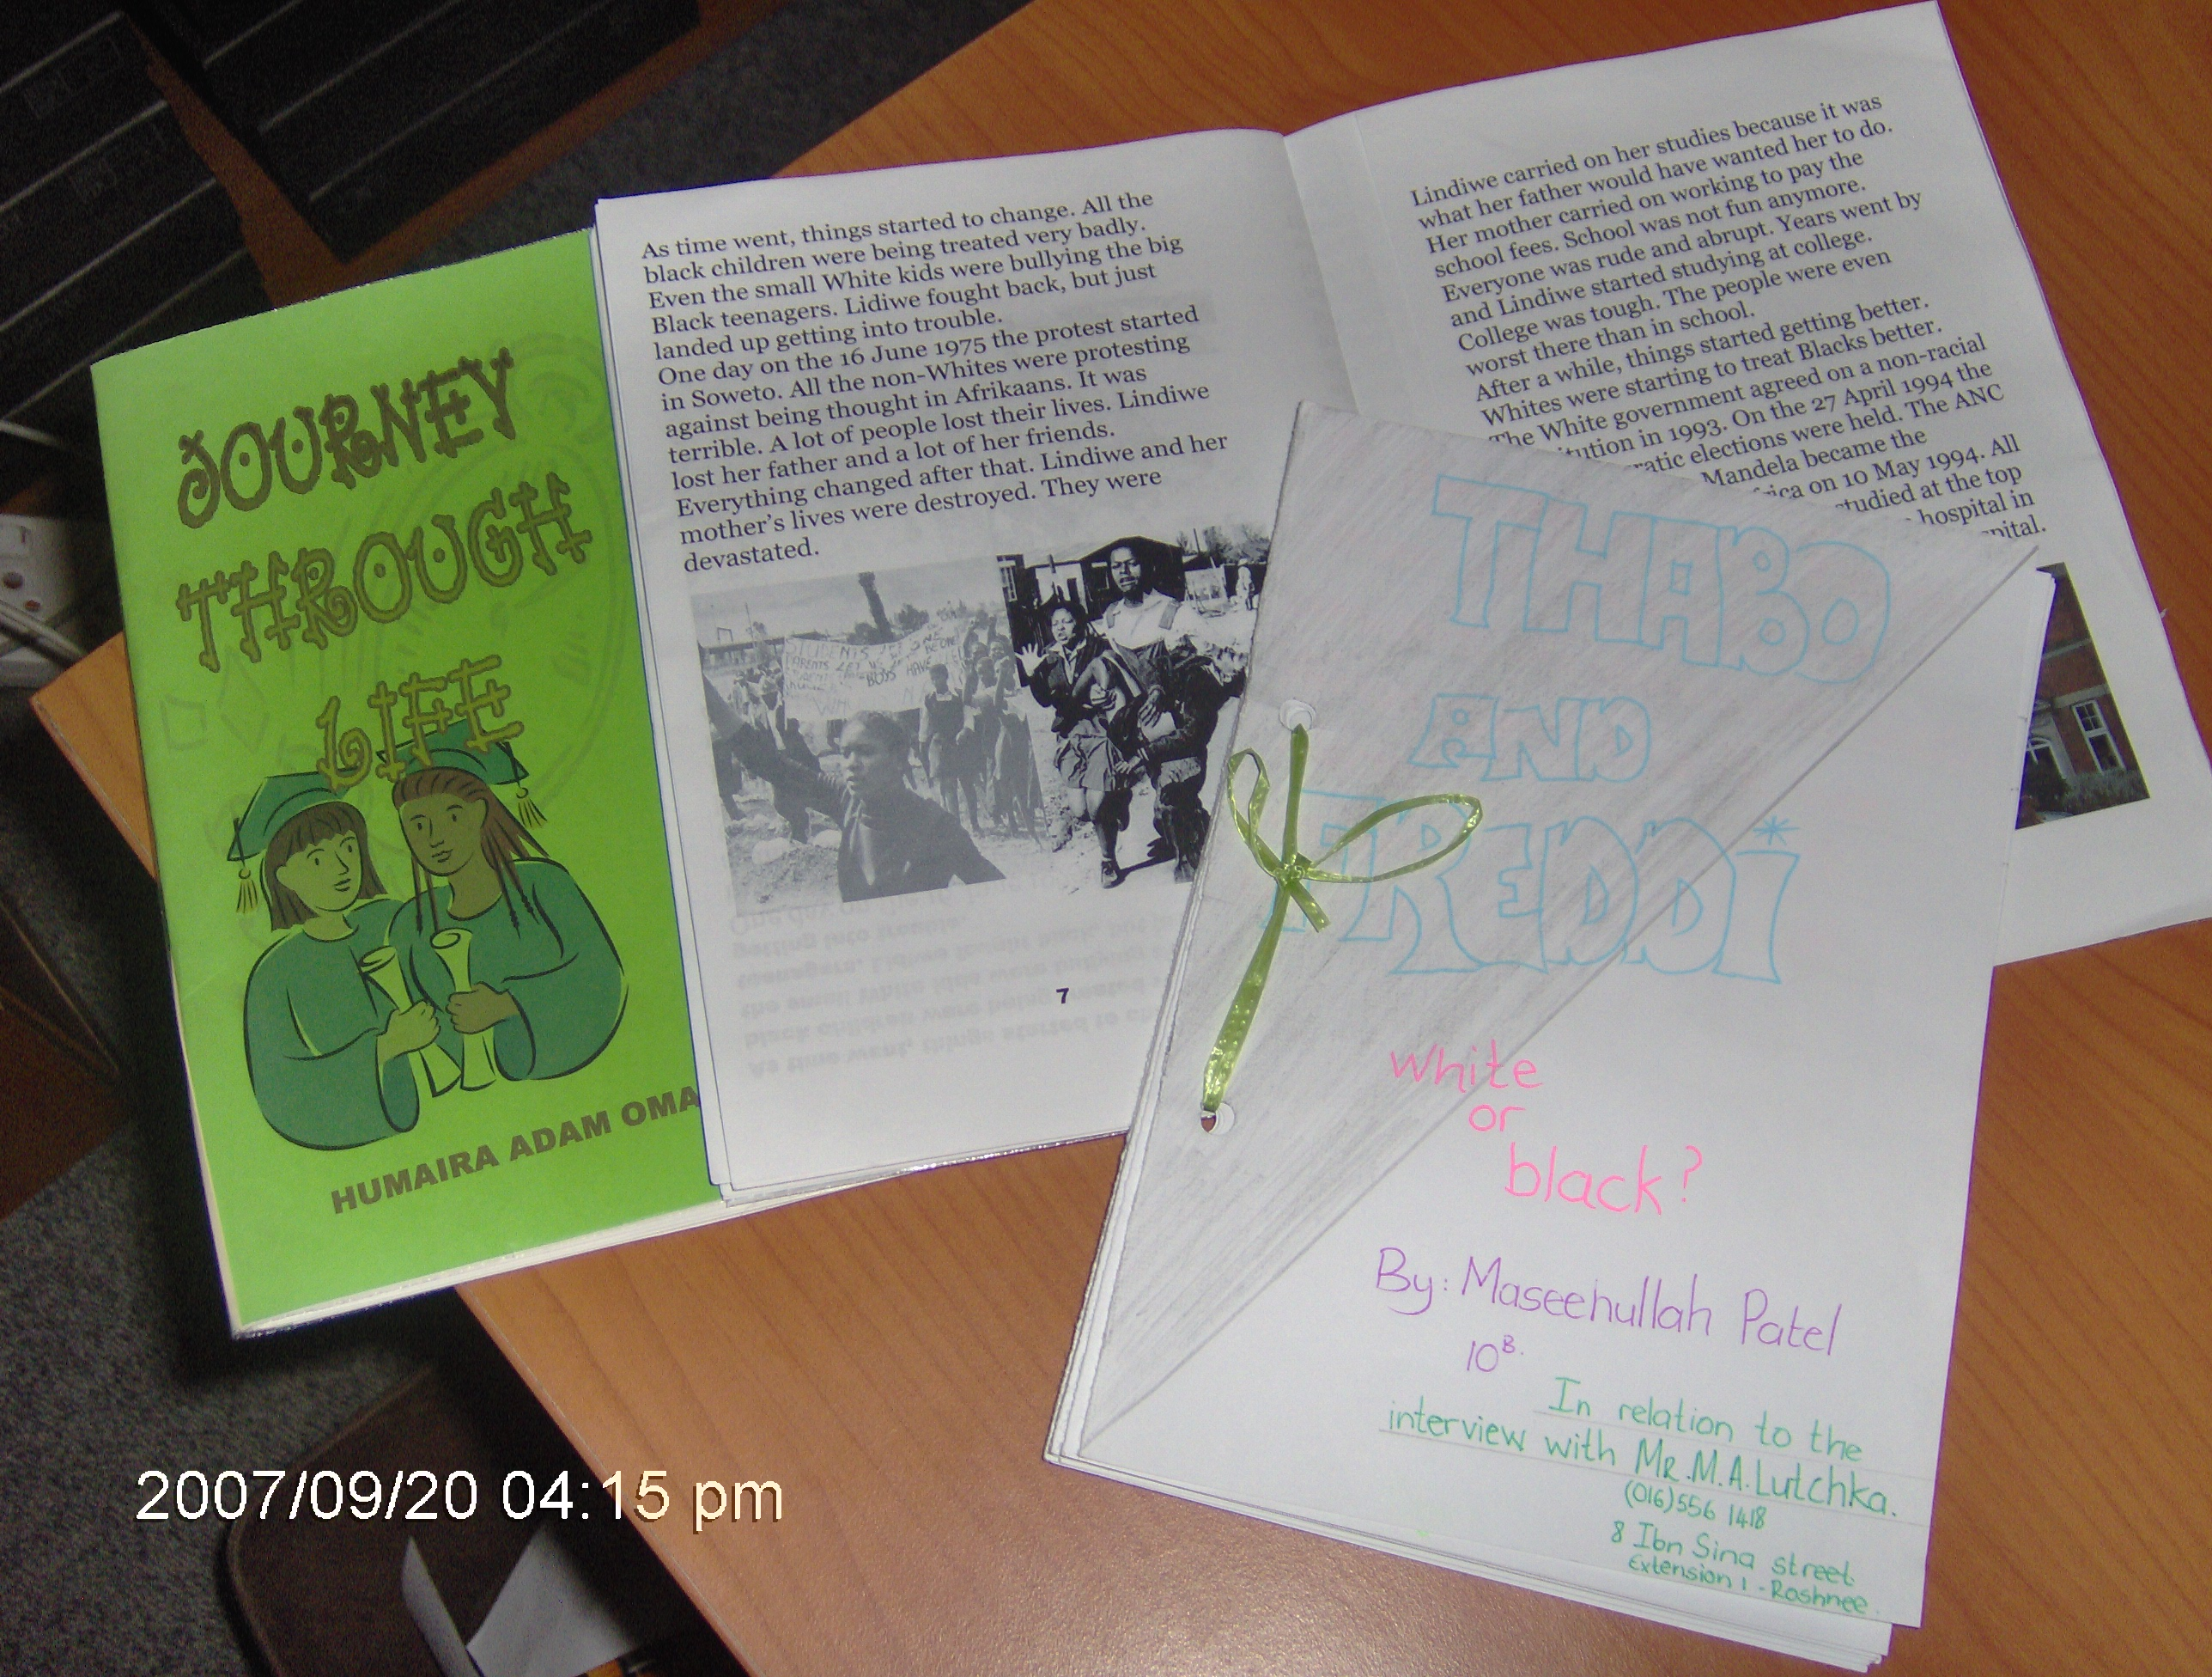
Copies of three books written for grade 4 – 7 on the TRC and the Vaal Hearings.

Below is the letter from Jeanette Le Fleur

